9.Create a simple cloud software application for Hospital information system for SIMATS Hospital using any Cloud Service Provider to demonstrate SaaS with fields of patient name, age, address, phone, email, Attender name, attender phone, doctor name, diseases, etc

Step 1:Create the form of Patient details

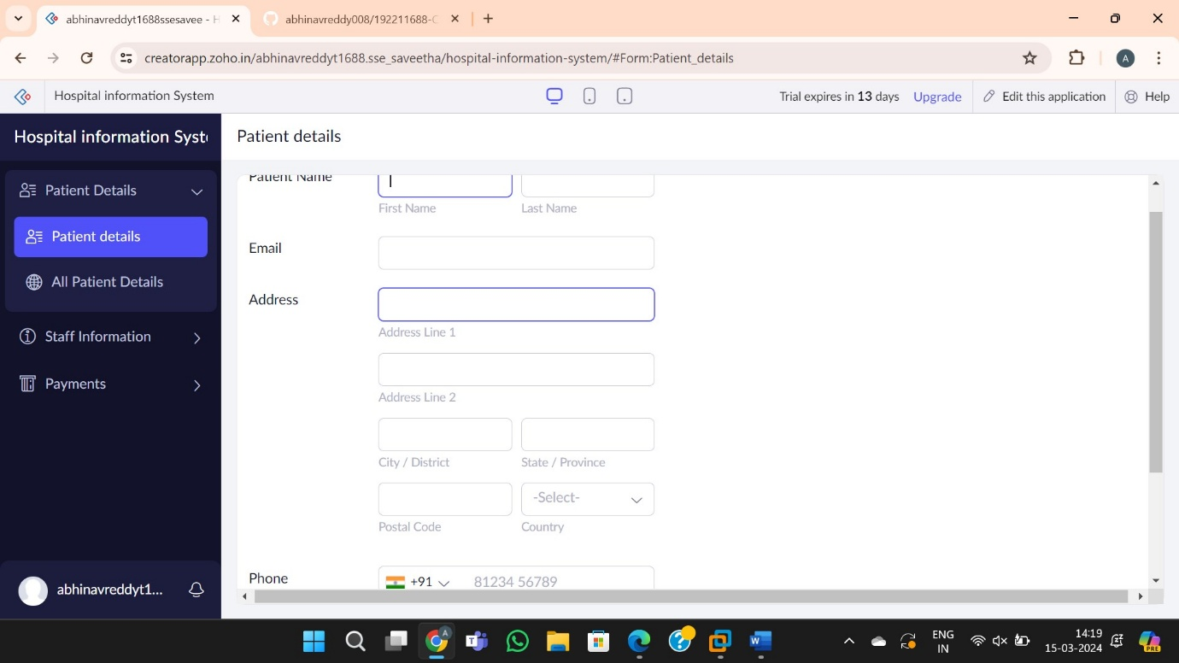

Step 2: Create the form for the staff information for attender name and number

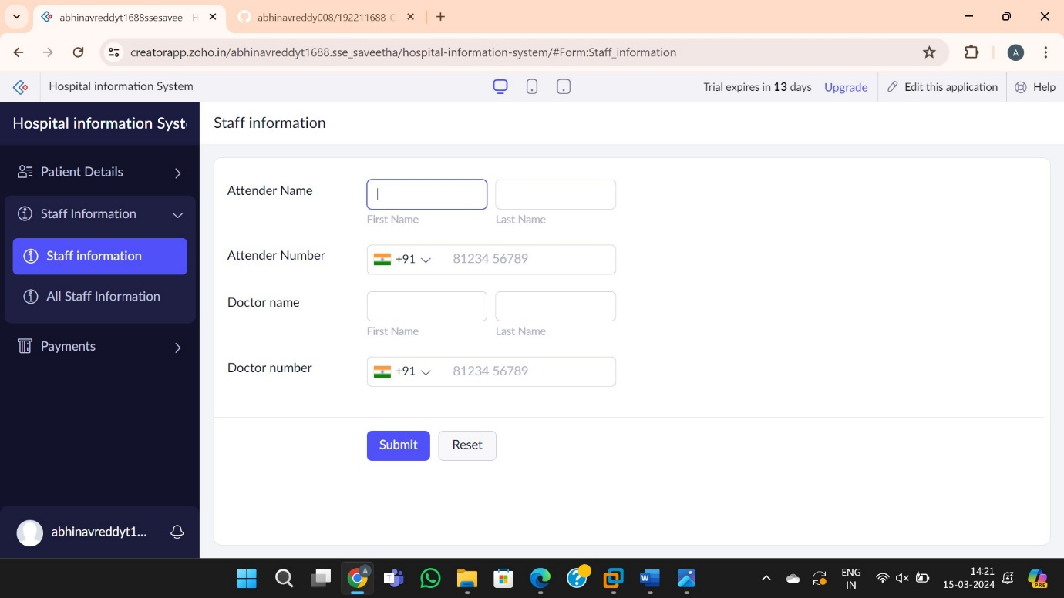

Step 3:Create the form of mode payments and discharge date

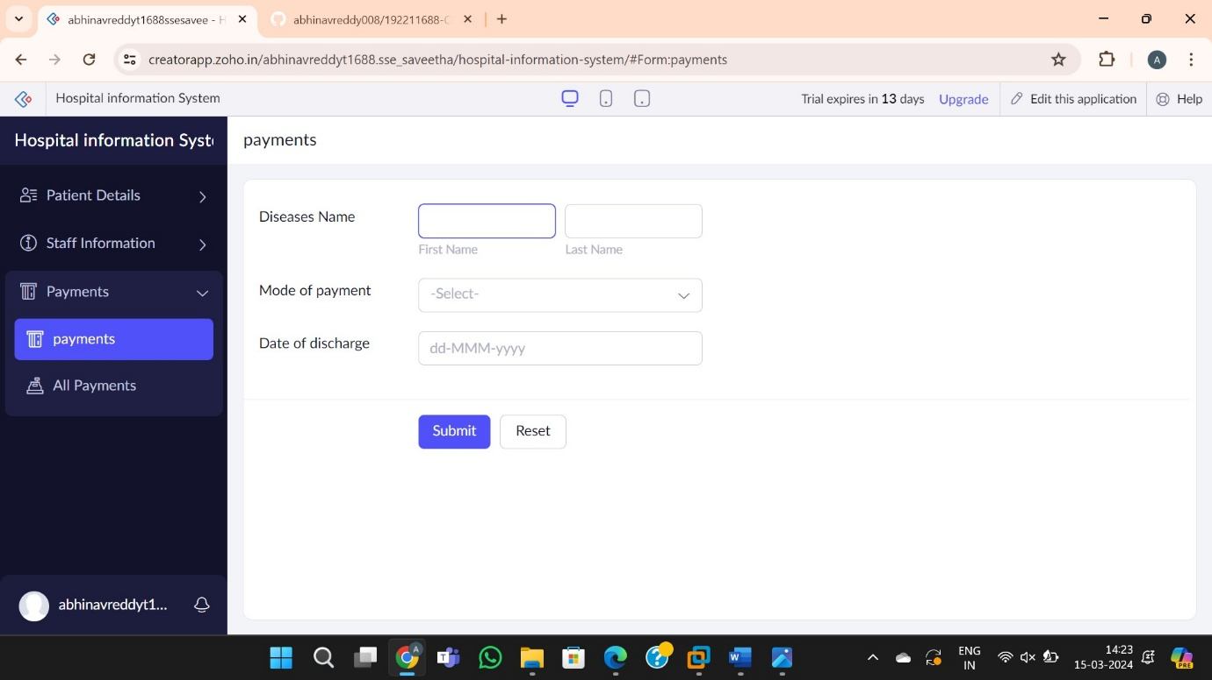

Step 4:Report forms of hospital information system

